**BENG 100 HW 6**

1a.

lambda = [1 5 15 25];

for i = 1:length(lambda)

y1a=poissrnd(lambda(i),1,1000)

hist(y1a)

figure

qqplot(y1a)

figure

end

Figures 1-8:









The Gaussian approximation is a good approximation of the Poisson PMF, as the rate increases. It is consistent with the Central Limit theorem, where lambda tending to infinity is equivalent to having a large number, n, of independent trials.

1b.

n = [15 25 50]

p = [.1 .3 .5]

for i = 1:length(n)

for j = 1:length(p)

y1b = binornd(n(i),p(j),1,1000)

hist(y1b)

figure

qqplot(y1b)

figure

end

end

x = rand(1,1)*5+3

y = poissrnd(x,[10,1])

Figures 1-18:







  










Above are the PMF figures for Binomial. Figures for QQ plots will be analogous to those above. As p << n and np tends to infinity, Binominal, Poisson, and Gaussian all have closely the same distribution.

d.

a=cumsum(rand(6,10000));

figure

subplot(2,1,1),hist(a(1,:),500)

title('Empirical CDF 1 sample')

subplot(2,1,2),qqplot(a(1,:))

figure

subplot(2,1,1),hist(a(2,:)/2,500)

title('Empirical CDF 2 samples')

subplot(2,1,2),qqplot(a(2,:)/2)

figure

subplot(2,1,1),hist(a(3,:)/3,500)

title('Empirical CDF 3 samples')

subplot(2,1,2),qqplot(a(3,:)/3)

figure

subplot(2,1,1),hist(a(4,:)/4,500)

title('Empirical CDF 4 samples')

subplot(2,1,2),qqplot(a(4,:)/4)

figure

subplot(2,1,1),hist(a(5,:)/5,500)

title('Empirical CDF 5 samples')

subplot(2,1,2),qqplot(a(5,:)/5)

figure

subplot(2,1,1),hist(a(6,:)/6,500)

title('Empirical CDF 6 samples')

subplot(2,1,2),qqplot(a(6,:)/6)

Figure 1-6













Doing exactly the procedure we mentioned will do the trick: take a sum of a collection of uniform random variables. This is a re-statement of the central limit theorem.

3c.

function HW6_3c

fun=(1/(sqrt(2*pi*3)))*exp(-((x+10).^2)/6);

x=-30.00001:30;

plot(x,fun,'c-')

end



function HW6_3c2

fun=(1/(sqrt(2*pi*3)))*exp(-((x-10).^2)/6);

x=-30.00001:30;

plot(x,fun,'c-')

end



3d.

function HW6_3d

fun= .5*((1/sqrt(2*pi*3)))*exp(-((x+10).^2)/6) + (1/(sqrt(2*pi*3)))*exp(-((x-10).^2)/6));

x=-30:.0001:30;

plot(x,fun,'r-')

end



3e.

normc=1;

v = 13.3;

vectoru = -2:0.01:2;

for i=1:length(vectoru),

u = vectoru(i);

plotXvector(i) = pdfX3cde(u,normc);

priorX = plotXvector(i);

likelihoodYgivenX = pdfYgivenX(v,u,muN,variN);

plot2Xvector(i) = priorX*likelihoodYgivenX;

end

normc = sum(plot2Xvector*0.01);

plot2Xvector = plot2Xvector/normc;

subplot(2,1,1);

plot(vectoru,plotXvector);

xlabel('u');

ylabel('f{X}(u)');

subplot(2,1,2);

plot(vectoru,plot2Xvector);

xlabel('u');

ylabel('f{X|Y}(u|13.3)');

function f=pdfX3cde(u,normc)

if 1<=u&u<=2

f=normc*(2-u);

elseif -2<=u&u<=-1

f=normc*(2+u);

else

f=0;

end

function f=pdfX(u,normc)

if 1<=u&u<=2

f=normc*(2-u);

elseif -2<=u&u<=-1

f=normc*(2+u);

else

f=0;

end

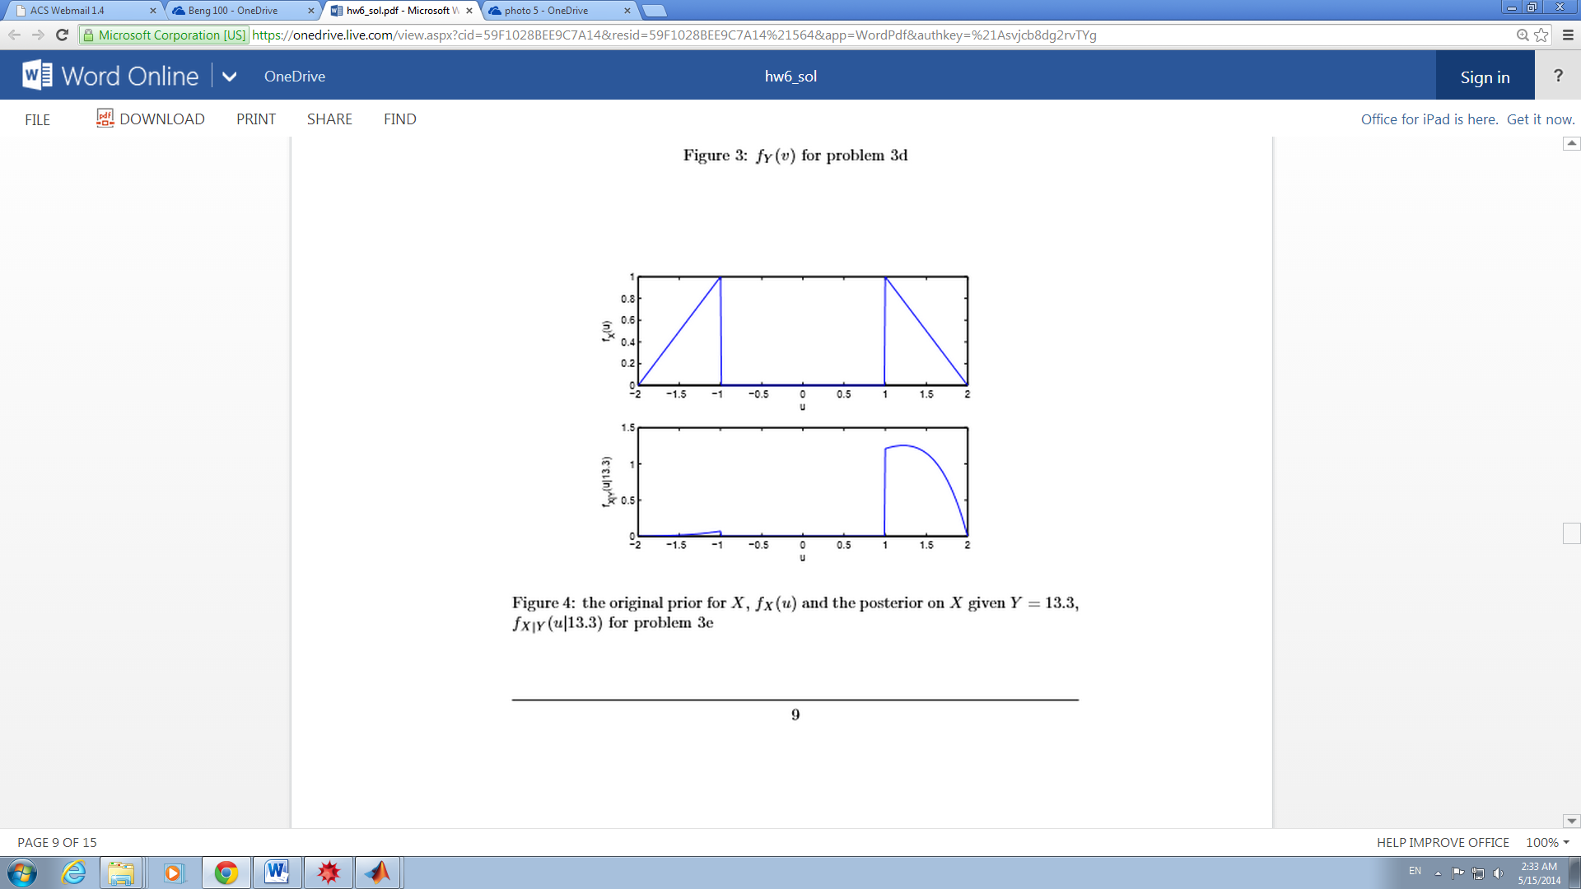

4a.

a=2.5;

b=5.5;

D=rand;

X=a*D+b

for i=1:10,

vectorY(i) = poissrnd(X);

end

vectorY

X =

6.4144

vectorY =

3 9 7 3 9 7 7 5 3 5

4c.

vectorU=3:0.0001:8;

for i=1:length(vectorU)

u=vectorU(i);

pdfXvector(i)=pdfX(u);

end

figure;

plot(vectorU,pdfXvector);

xlabel('u');

ylabel('fX(u)');

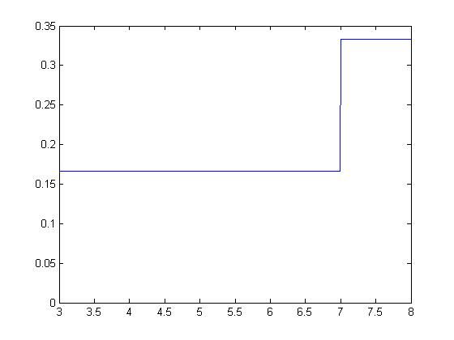

4e.

vectory = [5,4,6,3,2,3,4,3,5,2];

vectorN = [1,2,5,10];

for i=1:length(vectorN)

n=vectorN(i);

sumY=sum(vectory(1:n));

for i2=1:length(vectorU),

u=vectorU(i2);

vector2X(i,i2)=pdfX(u)*(u^sumY)*exp(-n*u);

end

normC = sum(vector2X(i,:)*0.01);

vector2X(i,:) = vector2X(i,:)/normC;

subplot(4,1,i)

plot(vectorU,vector2X(i,:));

xlabel('u');

title(sprintf('X|Y1 to Y{%d}',n));

end

end

function func=pdfX(u)

if 3<=u&u<= 7

func=2/3;

elseif 7<=u&u<=8

func=1/3;

else func=0;

end

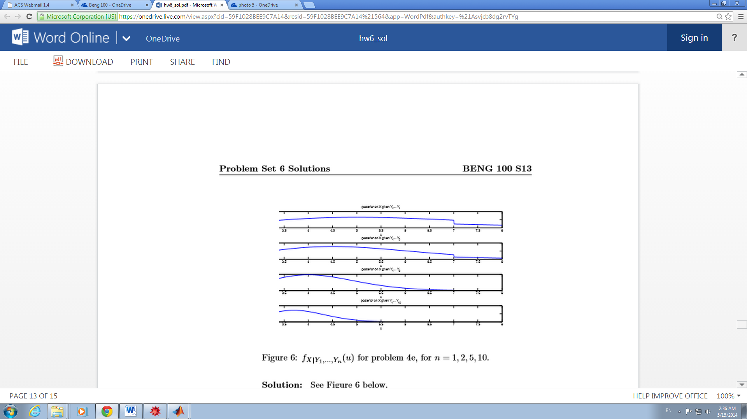

5f.

vectory=[5,4,6,3,2,3,4,3,5,2];

vectorN=[1,2,5,10];

for i=1:length(vectorN)

n=vectorN(i);

yvector(i)=sum(vectory(1:n))/n;

epsil(i)=4*sqrt(10/n);

confidence(i,1)=yvector(i)-epsil(i);

confidence(i,2)=yvector(i)+epsil(i);

end

disp(yvector)

disp(epsil)

disp(confidence)

5.0000 4.5000 4.0000 3.7000

12.6491 8.9443 5.6569 4.0000

-7.6491 17.6491

-4.4443 13.4443

-1.6569 9.6569

-0.3000 7.7000